**EMG 549 Introduction to Software Development and Architecture Assignment 2**

1. Analyze following cases:
   1. Analyze cases below explain each sections briefly and give your own opinion about the technology stack of your choice. Explain why you choose this stack.
      1. How to Choose Technology Stack: <https://svsg.co/how-to-choose-your-tech-stack/>
      2. Choosing the Right Software Stack: <https://www.upwork.com/hiring/development/choosing-the-right-software-stack-for-your-website/>
   2. Read pages at following links and explain apps technology stack used in development of following popular apps listed below. Please note Programming Language used, http server technologies, Server libraries, Database and NoSQL database, Cloud hardware infrastructure etc. Please explain significance of each of the sections and unique features for each of the 11 apps w.r.t software stack.
      1. Airbnb: <http://techstacks.io/airbnb>
      2. Uber: <http://techstacks.io/uber>
      3. Trello: <http://techstacks.io/trello>
      4. Dropbox: <http://techstacks.io/dropbox>
      5. Instagram: <http://techstacks.io/instagram>
      6. Slack: <http://techstacks.io/slack>
      7. Facebook: <http://techstacks.io/facebook>
      8. Spotify: <http://techstacks.io/shopify>
      9. Medium: <http://techstacks.io/medium>
      10. Yelp: <http://techstacks.io/yelp>
      11. Twitch: <http://techstacks.io/twitch>

3. Explain any 5 technologies explained at following link in 2 lines each: <http://techstacks.io/tech>

2. Please Analyze following WebApp design case study:

**a. 14 Technologies Every Web Developer Should Be Able to Explain**

<https://differential.com/insights/14-technologies-every-web-developer-should-be-able-to-explain/>

**b.** **Why DevOps, Integration, and Continuous Delivery Hold The Key to Enterprise Mobile App Dev** <https://www.forbes.com/sites/benkerschberg/2015/02/04/why-devops-integration-and-continuous-delivery-hold-the-key-to-enterprise-mobile-app-dev/#16ed2d043e5e>

c. Go to following **Amazon Web Services Mobile app case studies** page and select atleast 3 case studies and write few lines about each case study. Please explain Amazon Web Services tool being used by a given case study and how it changed their business and improved the bottomline.

<https://aws.amazon.com/solutions/case-studies/web-mobile-social/>

3. Please Analyze following Software Architecture and Software Development Case Studies:

a. What is Software architecture? [https://www.dropbox.com/s/d46jr3gothjcy1w/Chapter%201%3A%20What%20is%20Software%20Architecture%3F.pdf?dl=0](https://www.dropbox.com/s/d46jr3gothjcy1w/Chapter%25201%253A%2520What%2520is%2520Software%2520Architecture%253F.pdf?dl=0)

b. Clean Architecture: <https://8thlight.com/blog/uncle-bob/2012/08/13/the-clean-architecture.html>

4. Please explain your understanding of Software Architecture and software development process with an example in detail (1 page max)

5. Read through following cases and explain your understanding of the case studiest:

1. ForecastWatch.com Uses Python To Help Meteorologists. <https://www.python.org/about/success/forecastwatch/>

b. Gusto! Chooses Python for Travel Social Network Transition<https://www.python.org/about/success/gusto/>

5. What is github and version control. Create your own github account and upload some files there. Please attach a link.

6. What is API? What is RestAPI? Explain Restful API service and its application.

7. Following is Tweeter Tweepy package notebook on google colab.

a. Please change the searchQuery = 'Seattle'to searchQuery = 'San Francisco' and run the script again to see San Jose related tweets. Submit the wordcloud similar to the following for San Francisco. Submit the code. You will need to create your account and copy Secret Token and keys at <http://apps.tweeter.com>

Link to Seattle Tweeter Analysisn on Colab.

<https://colab.research.google.com/drive/1WIcVZgbrU0DYOQqaxuaCLKY6CoLBV18O#forceEdit=true&sandboxMode=true&scrollTo=timxX2vKBk3->

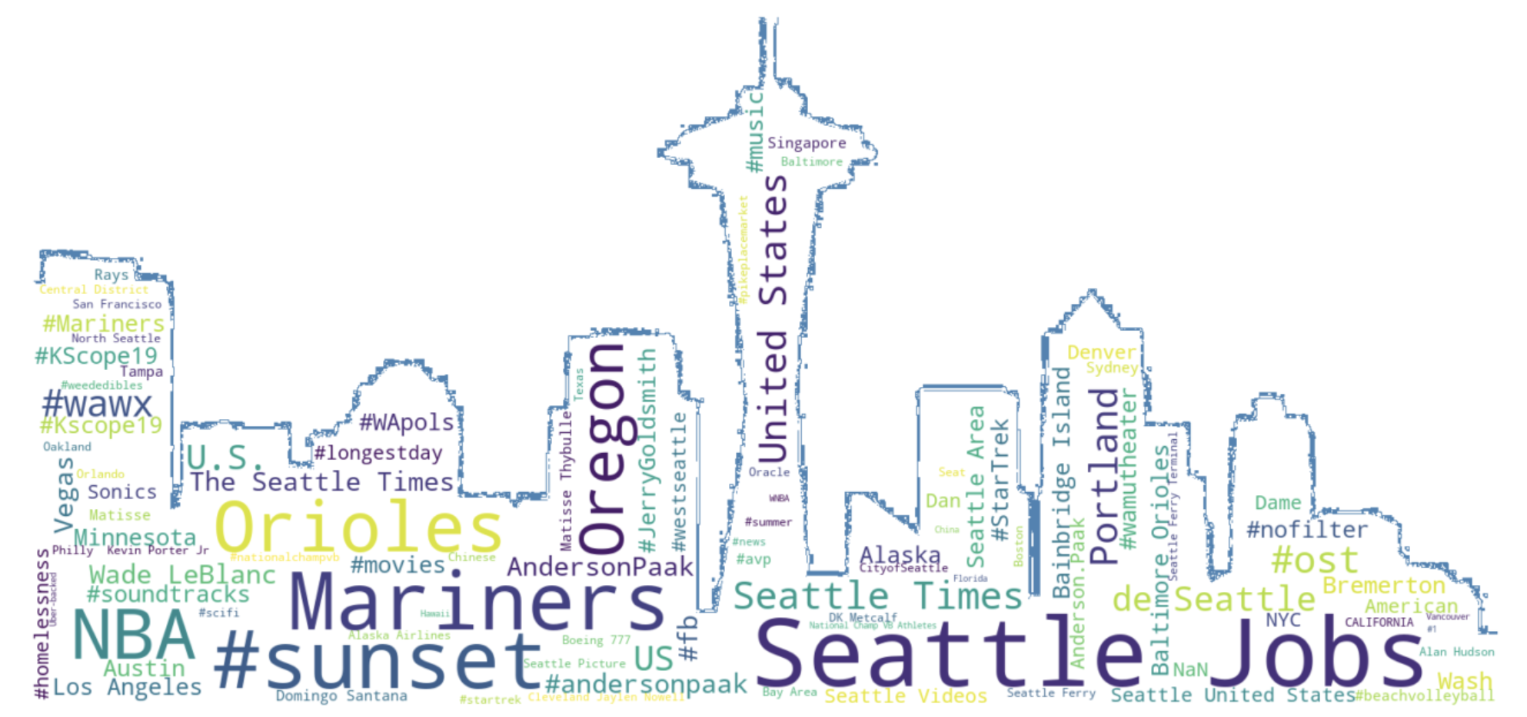

8. Following link shows method to plot SF Crime data on Map using Folium package in Python. Please run the code described in this link on Google colab and share code and describe your journey through the project.

<https://blog.dominodatalab.com/creating-interactive-crime-maps-with-folium/>